**Revision:**

**Revision history**

Describe the changes made and the reason for the change between the revisions.

|  |  |  |  |
| --- | --- | --- | --- |
| **Revision** | **Date** | **Description of changes** | **Author** |
| P1.0-1 | 2016-05-31 | Created draft version | Hariharan |
| P1.0-2 | 2016-06-09 | Refined after the meeting with Solution owner Tim & other stake holders | Hariharan |
| P1.0-3 | 2016-06-20 | Updated the NFR requirements | Hariharan |
| P1.0-4 | 2016-06-22 | Incorporated some of the review comments from Rahul. | Hariharan |
|  |  |  |  |

|  |  |
| --- | --- |
| **Reviewed/Approved** | **Name** |
| Yes/No |  |

Table of Contents

1 Introduction 4

2 Business current state / Solution 5

2.1 Capability description 5

2.2 Feature description 6

2.3 References 7

2.4 Open Issues 8

2.4.1 Response Time 8

2.5 Tech Stack 8

2.6 Landing to Microsite: 8

2.7 Content management Tools for Multilingual data 9

3 Solution Outline 10

3.1 Technical Architecture: 11

3.2 Business Requirements 12

4 Platform rules 13

4.1.1 IRW.RULE.TRACEABLE 13

4.1.2 IRW.RULE.ENABLEDISABLE 13

5 Non functional requirements 14

5.1 Responsiveness 14

5.2 Adaptability 14

5.3 Maintainability 14

5.4 Scalability 14

5.5 Accessibility 14

5.6 Performance Considerations 14

5.7 Browser Support 14

5.8 Security Considerations 14

5.9 Opportunities 14

5.10 SEO 15

5.11 Multi-lingual Support 15

5.12 Web Analytics 15

5.13 External Dependencies 15

6 Microsite Screens 16

6.1 Search Page:- (Before applying filters) 16

6.2 Job Search Page:- (after applying filters) 17

6.3 Results Page:- 18

7 Out of Scope 19

# Introduction

The objective of this solution is to redesign the current job search tool and develop one global solution and then replace the current tool on the following platforms.

1. IRW (FS)
2. IRW (MW)
3. New Web Platform (NWP)
4. IKEA Inside
5. ICO Worker.

This document describes the high level solution design approach of the Job Search tool.

# Business current state / Solution

Today in IRW the IKEA Jobs search page uses a custom solution to present dropdown options for searching all IKEA jobs, globally. The current functionality is difficult to maintain or change.

* Sub Issue 1: Current job search selection functionality is not available for internal candidates (IKEA Inside).
* Sub issue 2: Lack of interface between Kenexa and Job Search module. High manual maintenance effort on IRW, NWP and IBM.
* Sub issue 3: Job search functionality has language as first selection criteria and that needs to be changed to country as first selection criteria to allow a satisfying candidate experience. Moreover a suggestive search result in dropdown lists and a display of search results are requested enhancements.
* Sub issue 4: Not all countries are connected to the Job Search Tool on IKEA.com (for example, Russia) due to failure to integrate newly created Russian TG with a Job Search Tool.
* Sub issue 5: The current job search tool does not allow to switch on the WCAG technology for the responsive design candidate experience within Kenexa Brassring. This is preventing solution enhancement.

## Capability description

**Customer Benefits**

* Reduced Efforts – No efforts required on individual platforms. As the solution is generic, changes implement in microsite will reflect in all platforms.
* Better availability and usability of job search functionality for internal and external candidates.
* Easy maintenance of Job Search Tool values using API technology from ATS to the Job Search tool.
* Accessibility via mobile devices without losing core functionality.
* Better candidate experience.
* Better control on Look & Feel - Since we are extracting the kenexa response and we have the flexibility to control on Look & Feel.

## Feature description

The global solution will implement the following features:

1. Redesign how these dropdown values are served and update the IKEA Jobs search to use a Brassring API instead of a custom IRW solution.
2. Update all the dropdown values to be fetched from Brassring API.
   1. Change the display & order of the search criteria. ie Display the filter criteria of the search (candidate can always change the filter criteria) (Example from Benteler careerpage)
   2. Real time automatic synchronization of jobs and all search criteria (language, location, org unit, etc.) between ATS and new Job Search tool.
   3. Possibility to limit search filter values depending on a previous filter selected (for example, when a country is selected, availability of values in other filters would be limited to options for that country)
   4. Possibility to have specified filters available on a Job Search Tool and in the following order of display:
      * Country
      * Location
      * Work area
      * Part time/full time
      * Language
   5. Possibility to have keyword searches (nice to have requirements) with filter limitation.
   6. All filters can be selected separately without following an order.
   7. Display number of found jobs per selection once a criteria was selected
   8. Reset filter in different sub categories (see picture F10)
   9. After clicking 'show jobs' candidates will be directed into Kenexa Brassring. Source tracking is needed. Job search results shall be shown in Kenexa Brassring within the IKEA webpage.
   10. Advance search option will be provided in microsite. Click on advance search link will open kenexa Advance search page.
   11. Possibility to have a suggestive search (when a candidate starts typing a combination of letters possible suggestions appear).
   12. Possibility to get results in the keyword field regardless the language of query
3. Other Links stay the same on pages e.g. Log in to candidate profile
4. Need to have job search tool translated for labels and dropdown values in the following languages:
   1. Chinese
   2. Croatian
   3. Czech
   4. Danish
   5. Dutch
   6. English
   7. Finnish
   8. French
   9. German
   10. Hungarian
   11. Italian
   12. Japanese
   13. Korean
   14. Norwegian
   15. Polish
   16. Portuguese
   17. Romanian
   18. Russian
   19. Serbian
   20. Slovak
   21. Slovenian
   22. Spanish
   23. Swedish
5. New header & footer will be developed.
6. Russia will have little deviation from normal flow. ie If the user is Russian, he/she will be redirected to Avent system where his/her profile will be registered. Then the Russian user profile data flows from Avent DB to kenexa, and then only he will be allowed to apply for jobs.

## References

[1] BSGF_IKEA Jobs search tool Requirements Doc –

<https://service.projectplace.com/pp/pp.cgi/0/1231561036?direct=1231410099#/tab_>

[2] IBM Kenexa API Reference -

<https://service.projectplace.com/pp/pp.cgi/0/1197196474?direct=1231569121#/tab_>

[3]. Site Extension guideline reference

<https://service.projectplace.com/pp/pp.cgi/0/1231563340?direct=1253275997#/tab_>

## Open Issues

### Response Time

Expecting Response Time values for the below table from Business:

|  |  |
| --- | --- |
| Use Case | Response Time in Milli Seconds |
| Search page loading with all dropdown values |  |
| Update Total Job count in search page when criteria changes |  |
| Search Jobs without any filter criteria. |  |
| Search Jobs with Multiple filter criteria. |  |
| Keyword search. |  |
|  |  |
| Clicking Next page in Job Results. |  |
|  |  |

## Tech Stack

* + Java – 1.7 Version
  + Front Tier – Java script, Jquery, JSP, HTML & CSS. Ajax calls will be used for populating drop downs.
  + Integration Tier – Spring framework 3.0 , Spring MVC, Spring IOC, Kenexa webservice will be consumed in this layer.
  + Data Access Tier – Spring JDBC, Brass ring Kenexa API.
  + MySQL DB
  + IDE – Eclipse Mars 4.5.0.
  + Code Repository – Clear case
  + Development Web server – Apache Tomcat 8
  + Production Server – Tomcat on Linux server
  + Build tool - Jenkins

## Landing to Microsite:

All the platform’s current Job search tool link will be replaced with new microsite url. Parameters will be passed from source platform to microsite to identify the source platform & locale in the microsite. Based on the parameters passed, microsite will display the page in the appropriate language.

## Content management Tools for Multilingual data

The below CMS tools will be used for handling Multilingual data.

1. For IRW platforms, Team site will be used.
2. For NWP, Web Center site will be used.

# Solution Outline

The existing Job Search tool will be redesigned in to new Global solution. The new Global solution will have its own header, banner, footer, menu as per Ikea Look and feel guidelines. The back end kenexa brassring api will be reused as it is. Current Job search tool will be replaced with the url of this Global solution.

This global solution will have the following layers.

**Front End Layer**: This layer will capture the user inputs (search parameters) and will display the data (search results) to the candidate.

**Integration Layer**: This layer will have business logic. Based on user supplied parameters , this layer will either query the local JST DB or Kenexa and returns the data to UI tier. For keyword search, this layer will query the kenexa DB directly. If it is kenexa call, this layer forms the input request message (XML format) and passes the request to Kenexa layer. It gets response from Kenexa & passes the data to presentation layer.  It will then invoke a call to the Kenexa Brassring API and returns the response message (XML format).

**Data Access Tier:** This tier will always query the JST DB for populating drop downs & Table. Existing Kenexa API webservices will be consumed.

**Local JST Database:** In order to get the data quickly in search page, we will set up a local database ie JST DB in Ikea environment. Cron jobs will be triggered at suitable intervals to copy the Kenexa DB data to local JST DB. Cron jobs will pick only the delta (fresh) data and populate the JST DB. The Job table will be partitioned for Country Id / Language Id for efficient retrieval. Expired jobs will be removed from JST DB. The JST DB will have the following details. Job Id, Title, Description, Work Area, Location, Country, Last Updated Date, Link,(Kenexa Link to job detail), Language, Expiry date, Kenexa Gateway ( Global External, Global Internal, Global Russian, Internal Russian, Language) , ATS Type, Job Type (Full time or Part time).

## Technical Architecture:

## Business Requirements

From [1] the following scenarios have been extracted.

|  |  |  |
| --- | --- | --- |
| **Ref Id** | **Name** |  |
| Scenario 1 | The user can login in to ikea.com, then clicks on any market (IRW/NWP). Then clicking on JST Link, he/she will be redirected to Microsite. Then he/she can search for available jobs. |  |
| Scenario 2 | The user can login in to Ikea inside. Then clicking on JST Link, he/she will be redirected to Microsite. Then he/she can search for available jobs. |  |
| Scenario 3 | The user can login in to ICO worker. Then clicking on JST Link, he/she will be redirected to Microsite. Then he/she can search for available jobs. |  |
| Scenario 4 | The user can directly login to microsite with the url and search for available jobs. |  |
| Scenario 5 | The user can search for jobs by clicking search button without logging in to kenexa portal. |  |
| Scenario 6 | The user can also search for jobs by clicking Advance search button. |  |
| Scenario 7 | The user can get job details by clicking the link in the job results page in the search results page. |  |
| Scenario 8 | The user can directly login in to kenexa using ‘Log in to candidate profile’ and search for jobs. |  |
| Scenario 9 | The user will be forced to login to kenexa when he tries to apply jobs from microsite |  |
| Scenario 10 | The user can see his profile details, applied jobs summary, job status, after logging in to kenexa portal.(out of scope for this application) |  |
| Scenario 11 | The user can register his profile by filling the mandatory forms. (out of scope for this application) |  |
| Scenario 12 | The user can register his profile by using Linked-in account or face book Account.(out of scope for this application) |  |

*This section describes platform specific rules that should be considered in the design and implementation of the requirements. If IT-requirement exists for the solution, the Rules can be found in the IT-requirement.*

# Platform rules

*This section describes platform specific rules that should be considered in the design and implementation of the requirements. If IT-requirement exists for the solution, the Rules can be found in the IT-requirement.*

### IRW.RULE.TRACEABLE

Clear case will be used to version control (lifecycle) this change.

### IRW.RULE.ENABLEDISABLE

NA.

# Non functional requirements

## Responsiveness

Pages developed in Microsite will be developed in responsive manner. i.e the global solution developed should fit in Web, Mobile Web & Ipod.

## Adaptability

* Integration layer (Java layer) integrates with Kenexa API through request/response xml messages.  Based on front end form parameters, request xml is formed in Integration layer. The xml structure is defined by Kenexa.
* The interfaces will be designed in a more abstract / generic way that will allow for easy extension to other ATS. i.e. Integration tier is  kept loosely coupled with Kenexa which will give flexibility for adding any another ATS in the future.
* **Switching to different ATS** - Code changes required in Integration layer in order to form the request message as per  New ATS tool standards. The amount of rework depends on new ATS’s request/response format i.e. XML or JSON or any other structure.

## Maintainability

Since all the platforms use a Global solution it will be easy to maintain. i.e. Changes implemented in Global solution will reflect in all platforms.

## Scalability

NA

## Accessibility

Solution accessibility should be **‘AA’** compliant.

## Performance Considerations

Local JST DB will be used to optimise the performance.

## Browser Support

1. Global browsers with fast update pace. - Firefox 47.0 & 46.0 , Chrome 51.0.2704 & 50.0.2661
2. Global browsers with slow update pace. - Safari 5, 4 & 3, IE 11, 10 & 9 and Edge 25, 23 & 21.
3. Local/regional browsers those are very common in a specific market - Yandex 16 & 15. (Russia)

## Security Considerations

SSL enabled and within ikea.com domain. Solution will be tested for standard ikea security tests such as SQL injection, Cross-site scripting & hacking.

## Opportunities

NA

## SEO

Solution follows the SEO guidelines such as Editable page title, metadata, URL, headings and page content should be part of new solution. Ikea DNS naming standards will be followed. To get better ranking in search engine, Microsite will be hosted with in ikea.com as sub domain using Site Extensions. For eg [www.ikea.com/ext/JobSearchTool](http://www.ikea.com/ext/JobSearchTool).

## Multi-lingual Support

* Job search tool will support the following languages i.e . labels and dropdown values will be translated in the following languages:
  + Chinese
  + Croatian
  + Czech
  + Danish
  + Dutch
  + English
  + Finnish
  + French
  + German
  + Hungarian
  + Italian
  + Japanese
  + Korean
  + Norwegian
  + Polish
  + Portuguese
  + Romanian
  + Russian
  + Serbian
  + Slovak
  + Slovenian
  + Spanish
  + Swedish

## Web Analytics

Standard web analytics measurements will be done ie Number of users visiting the Job Search page & Job results page will be tracked. Solutions will be developed as per the web analytics guidelines from Ikea.

## External Dependencies

NA

# Microsite Screens

## Search Page:- (Before applying filters)

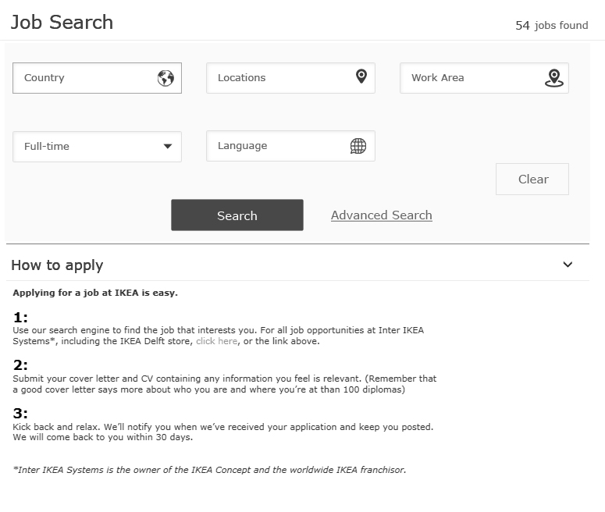

# 

## Job Search Page:- (after applying filters)

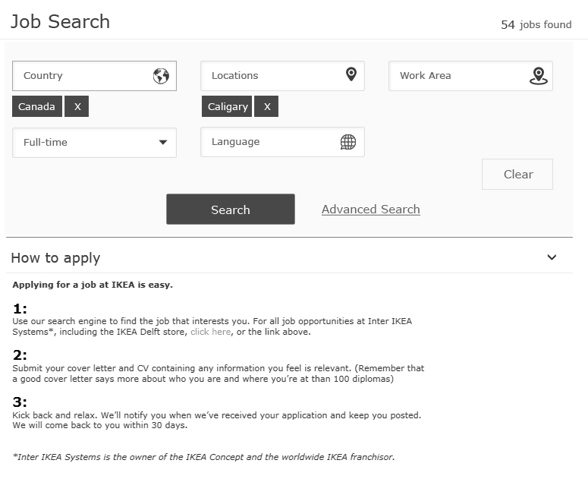

## Results Page:-

**Note:** This is not a direct brass ring page. The brass ring output is extracted and page is customized as per ikea look & feel guidelines..

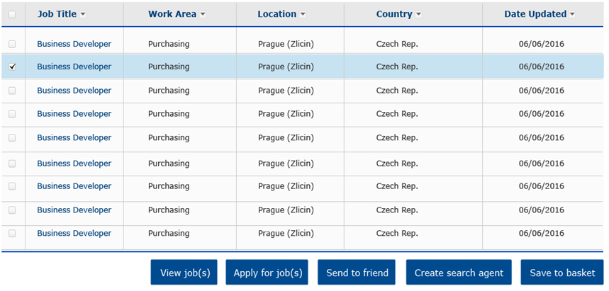

# Out of Scope

1. Global rollout to all markets.
2. Removing the Existing Job search tool from all platforms and linking to microsite is out of scope of this project. i.e removing the current page & updating the page with microsite url.
3. Any modifications to Kenexa api .
4. Making kenexa pages responsive is out of scope for this development.
5. Once the application navigates to kenexa portal, it is not under the scope of Microsite.